TO CREATE DATABASE

create database demo;

TO CREATE TABLE

create table demo.employee (Id int, Name string , Salary float);

TO DESCRIBE ABOUT TABLE

describe demo.employee;

TO CREATE NEW DIRECTORY

hdfs dfs -mkdir /HiveDirectory

TO CREATE DIRECTORY FOR FILE

hdfs dfs -put hive/emplist /HiveDirectory

TO CREATE EXTERNEL TABLE

create external table elist (Id int, Name string , Salary float)

row format delimited

fields terminated by ','

location '/HiveDirectory';

TO PRINT EXTERNEL TABLE

select * from elist;

TO ALTER TABLE

Alter table elist rename to employee_data;

TO CREATE VIEWS

CREATE VIEW emp_30000 AS

SELECT * FROM employee_data

WHERE salary>30000.0;

SELECT * FROM emp_30000;

FUNCTIONS:

select Id, Name, sqrt(Salary) from emplist ;

select Id, Name, round(Salary) from emplist ;

DATABASE CREATION

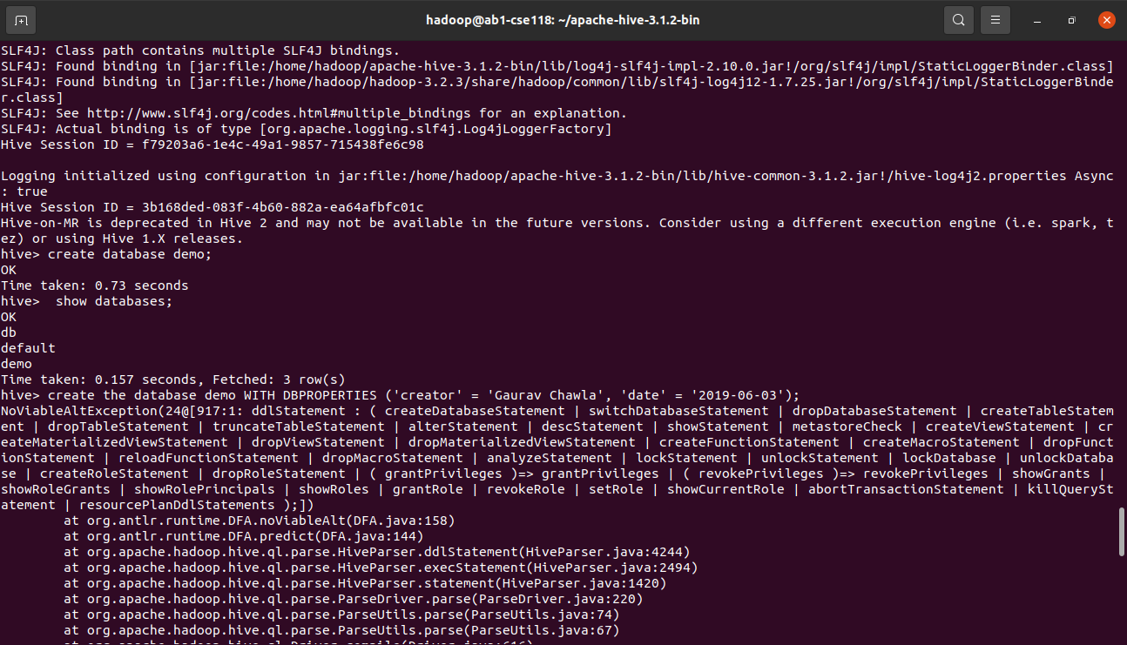

TABLE CREATON

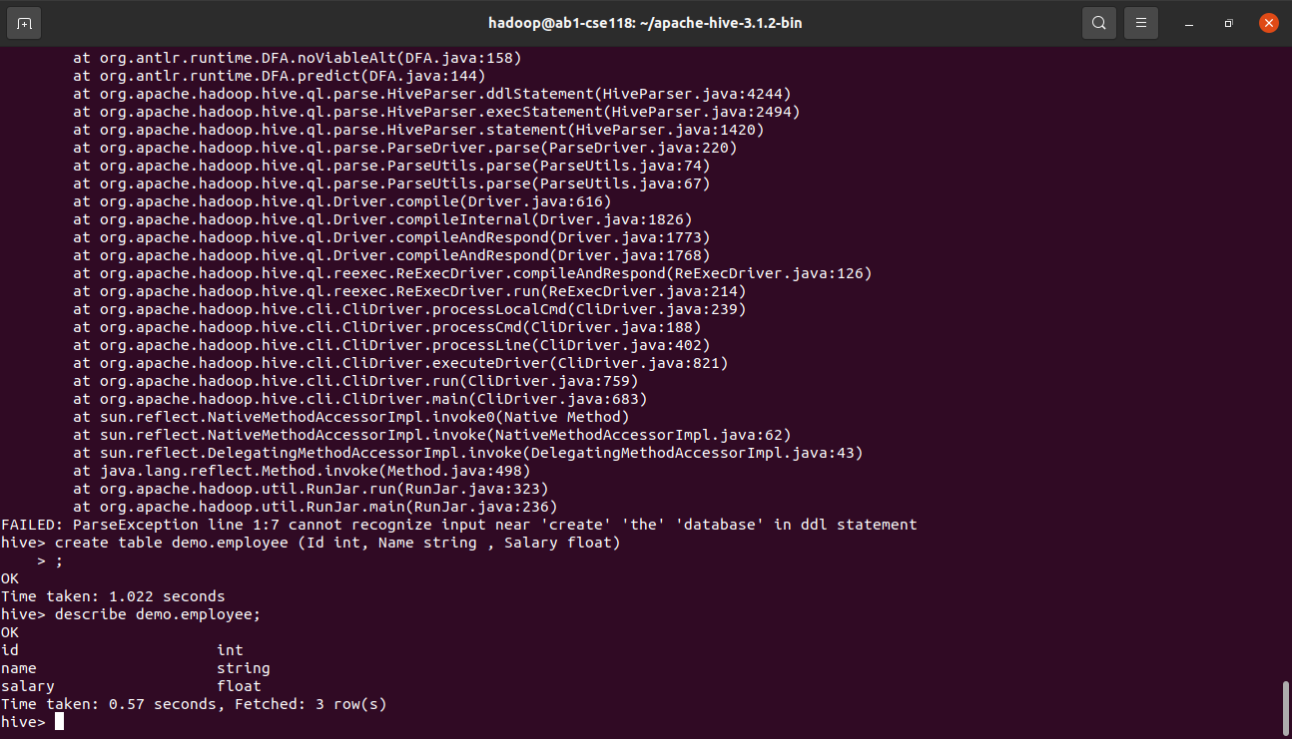

CREATE DIRECTORY

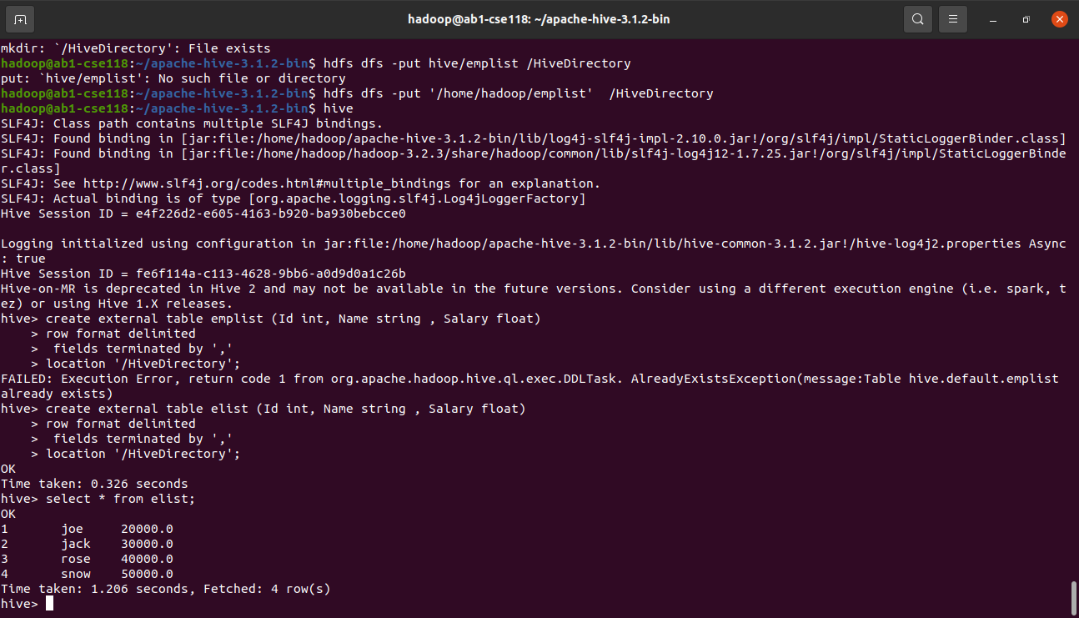

CREATE EXTERNAL TABLE

3



CREATE VIEWS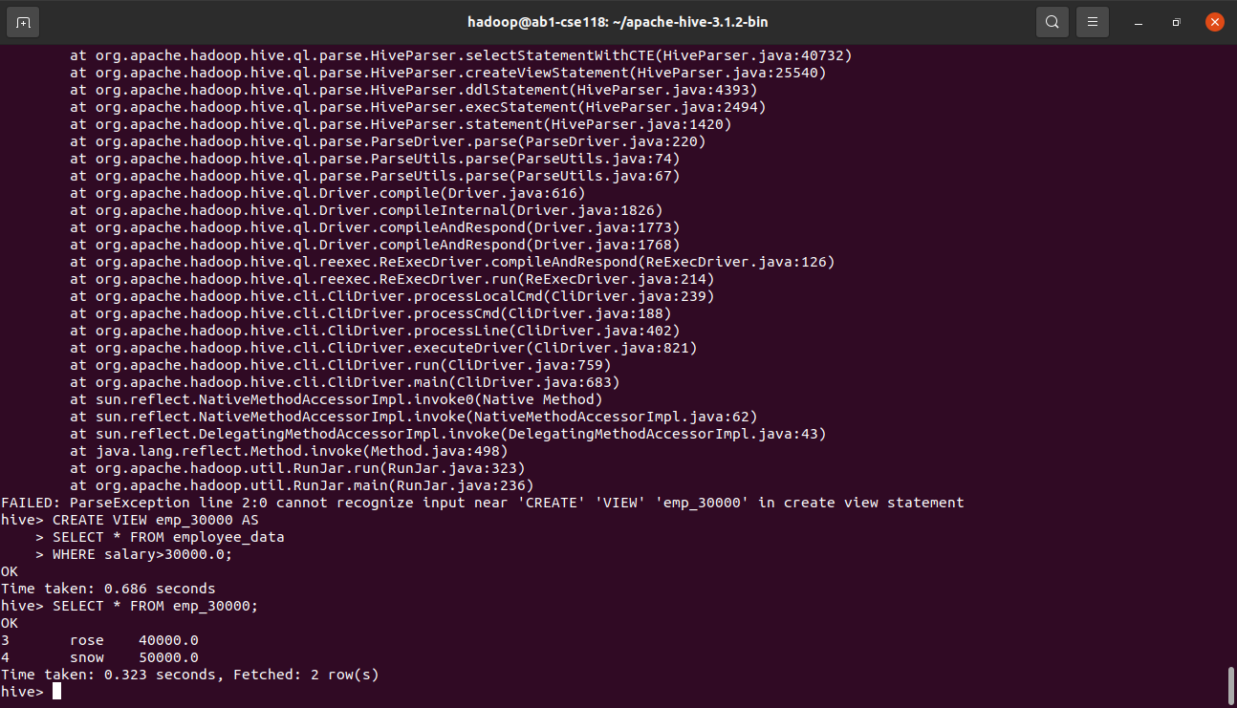

FUNCTIONS

